**EXECUTION PROCEDURE AND TESTING:**

In order to run the code, arduino IDE is required. The open-source Arduino Software (IDE) makes it easy to write code and upload it to the board. This software can be used with any Arduino board. Web version is also available. Steps to install arduino IDE into local device.

**INSTALLATION GUIDE FOR ARDUINO IDE:**

1. goto <https://www.arduino.cc/en/software> and download the file as per your requirement.

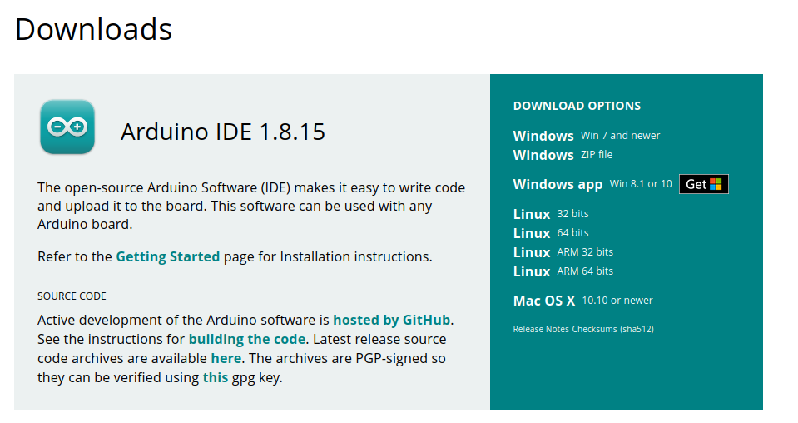

download options

1. For windows users, simply run the file downloaded from the software page and DONE.

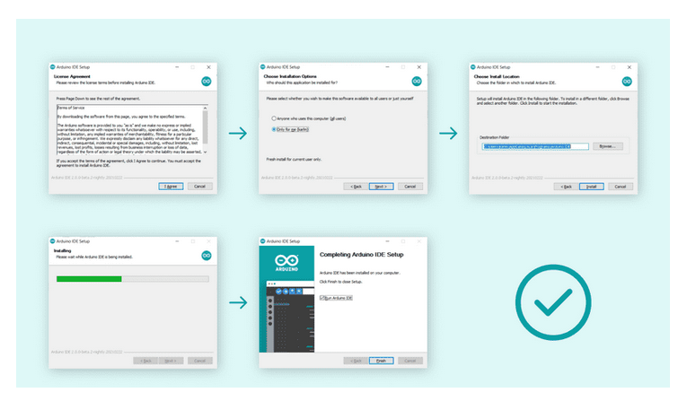

windows installation

1. For mac users, simply copy the downloaded file into your application folder and DONE.

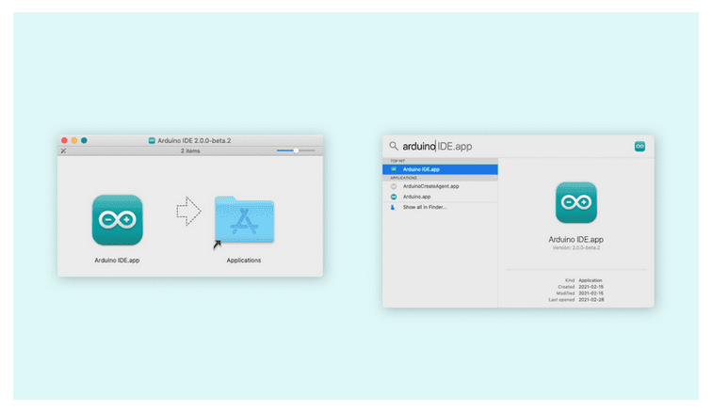

1. For linux users, simply extract the downloaded file to a suitable folder. Now, navigate to the folder, right click on it and select run in terminal. Finally, to launch the editor type ./arduino-ide and DONE.

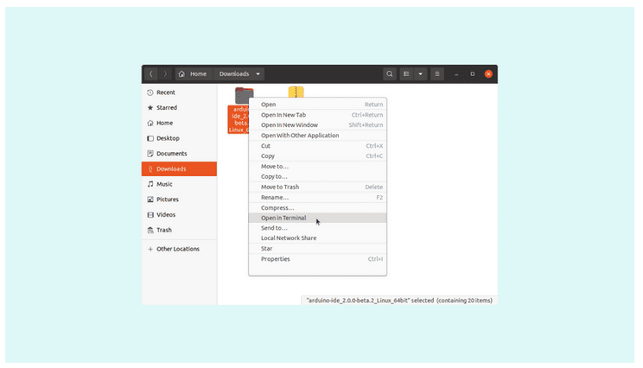

After installing arduino ide, launch the arduino IDE in your local system. Create two new projects and name them as arduino-DATASEND and nodemcu-RECEIVED.

1. Open arduino-DATASEND project and copy the arduino code which is written and paste it.
2. Goto Tools and click on boards. Inside boards, select arduino uno. Now, inside the Tools, goto port and choose the port from which the arduino uno board is connected.
3. Now, goto sketch and click on verify/compile. The code will be verified and compiled and displays if there are any errors.
4. Finally, click on upload to load the code into the arduino board

On the other hand,

1. goto nodemcu-RECEIVED project and copy the nodemcu code and paste it here
2. Goto Tools and click on boards. Inside boards, select nodemcu 1.0 board. Now, inside the Tools, goto port and choose the port from which the nodemcu board is connected.
3. Now, goto sketch and click on verify/compile. The code will be verified and compiled and displays if there are any errors.
4. Finally, click on upload to load the code into the nodemcu board

**Note:**

* If the nodemcu board is not available, then goto board manager and download it.
* Before uploading the code, remove TX and RX connections and connect it after both codes are being uploaded.
* Some of the libraries are not pre-installed.

**THINGSPEAK GUIDE:**

Thingspeak is the website used to store the sensor data into cloud. Steps to create a free account and how it being used.

1. Goto <https://thingspeak.com/> and click on sign in. If account already exists, login with your credentials. Or create a new account.

thingspeak

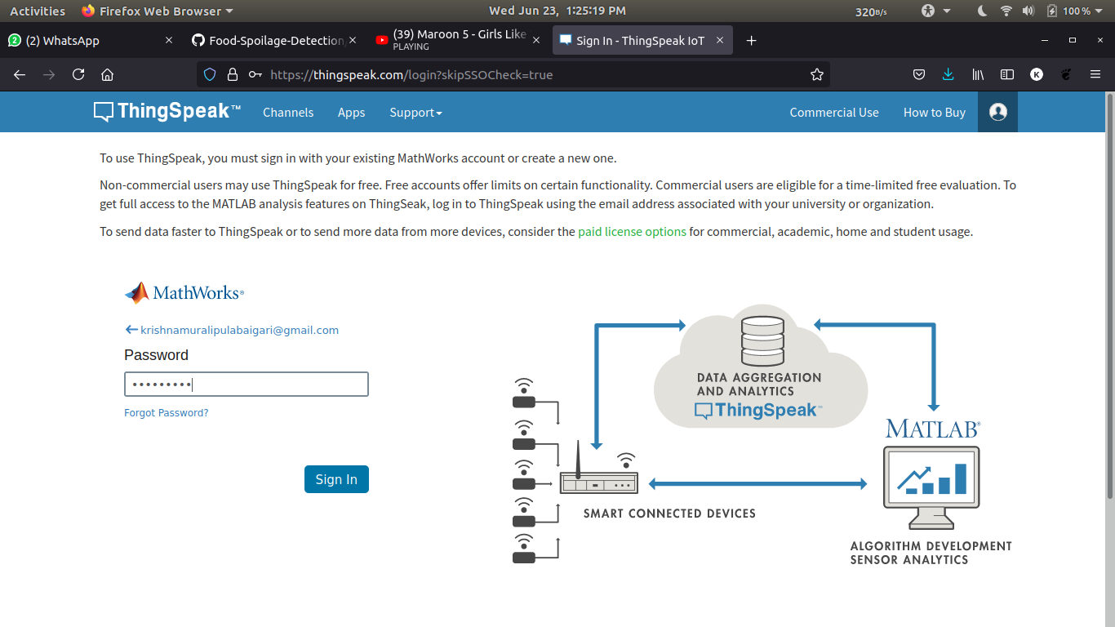

1. Goto channels and create a new channel. Type the details as mentioned below:
   1. Name as Food Spoilage Detection
   2. Field 1 as temperature
   3. Field 2 as humidity
   4. Field 3 as MQ2
   5. Field 4 as MQ3
   6. Field 5 as MQ4
   7. Field 6 as MQ135
   8. Field 7 as LDR
2. Click on save channel.

**IFTTT guide:**